Range disjunctions, managed hybridization, and reintroduction shape the conservation strategy for the endangered Physaria globosa (Brassicaceae)

Wen-Hsi Kuo¹, Clara Landon ^{1,2, 3}, Burgund Bassüner¹, Alexander G. Linan¹, Tara R. Littlefield^{4,5}, Matthew A. Albrecht¹, Christine E. Edwards¹*

¹Missouri Botanical Garden, 4344 Shaw Blvd., St. Louis MO 63110, USA
²Oberlin College Biology Department, 119 Woodland St., Oberlin, OH 44074
³Current address: Lady Bird Johnson Wildflower Center, 4801 La Crosse Ave. Austin, TX 78739
⁴ Office of Kentucky Nature Preserves, 300 Sower Blvd, Frankfort, KY 40601
⁵ University of Kentucky, Lexington, KY

*Correspondence: Christine.Edwards@mobot.org

Abstract (245 words)
Population genetic analyses of species of conservation concern can directly inform management strategies aimed at maintaining genetic diversity across natural, translocated, and ex situ populations. Physaria globosa, a federally endangered mustard, has a geographically restricted and disjunct distribution across river systems in Indiana, Kentucky, and Tennessee in the United States. We sampled populations across the species’ range, including 14 natural, 2 translocated, and 1 ex situ populations, and genotyped 358 individuals at 20 microsatellite loci. Genetic variation in the natural populations was strongly structured into 2 major geographic groups, a northern group in Indiana and Kentucky and a southern group in Tennessee, with significant isolation-by-distance (IBD) across the range. Several natural populations showed evidence of reduced genetic diversity, inbreeding, or recent bottlenecks, consistent with demographic decline and ongoing pressures such as habitat degradation and competition from invasive plants. In contrast, a translocated population of mixing two nearby natural populations, an ex situ population of mixing geographically distant populations, and a translocated population derived from this ex situ population, demonstrate the use of genetic mixing in maintaining or enhancing genetic diversity. Our results indicate that conservation of P. globosa should prioritize the protection of multiple populations within each major geographic region while also using ex situ and translocation management to capture and maintain diversity from vulnerable or inaccessible sites. More broadly, this study shows that genetic mixing and translocation can be effective tools for conserving genetic variation in endangered plants with disjunct distributions and degrading habitats.
Keywords: Genetic structure; genetic mixing; conservation management; microsatellites; translocation; ex situ conservation

Introduction (824 words)
Genetic diversity is widely recognized as the raw material underlying phenotypic and functional variation within species, and its maintenance is a central goal of biodiversity conservation (Shaw et al., 2025). Higher levels of genetic diversity are often associated with greater resilience, evolutionary potential, and individual fitness, and can also improve the establishment and persistence of reintroduced populations (Hoelzel et al., 2019). For narrowly distributed species of conservation concern, preserving genetic diversity therefore requires consideration of both natural populations and ex situ collections, as well as any reintroductions derived from them (Aguilar-Gómez et al., 2025).
Conservation strategies for genetically depauperate species generally span a continuum from protecting and reconnecting extant populations to more interventionist approaches involving translocation and genetic mixing (Bucharova, 2017; Gaitán-Espitia & Hobday, 2021). In plants, these interventions can include assisted gene flow among natural populations, managed interbreeding among geographically isolated populations, and reintroduction or population reinforcement using ex situ-derived genotypes to promote interbreeding and restore genetic variation (Edwards et al., 2025). Such actions can be valuable when fragmentation, demographic decline, or habitat change have reduced effective population size and limited natural gene flow, as they can increase genetic diversity, reduce inbreeding, and potentially enhance fitness and longer-term adaptive potential. However, outcomes are context dependent and not always predictable, thus their application remains debated (MacDonald et al., 2025).
Genetic mixing, managed interbreeding, and other forms of assisted movement raise several general questions in conservation genetics. Do disjunct populations represent distinct historical or adaptive components that should be protected separately (Fraser & Bernatchez, 2001)? Under what conditions does the risk of inaction exceed the risk associated with admixture? Can managed ex situ populations capture sufficient genetic diversity to justify their use in reintroduction and how much divergence among source populations is acceptable? The major concerns are well known: introduced gene flow may cause outbreeding depression, disrupt local adaptation, or generate maladapted genotypes (MacDonald et al., 2025); hybridization can also lead to genetic or demographic swamping if rare lineages are overwhelmed by admixture (Aguilar-Gómez et al., 2025); and translocations may generate ecological mismatches in recipient environments (Bucharova, 2017). In addition, small, inbred but viable populations may have already purged some deleterious recessive alleles, such that genetic rescue could introduce new genetic load and reduce fitness (Dussex et al., 2023). These risks do not preclude intervention but underscore the need in identifying a clear biological and demographic rationale, careful evaluation of risks to both source and recipient populations, and integrating post-release genetic monitoring to assess outcomes (Linan et al., 2024; Aguilar-Gómez et al., 2025).
Short’s bladderpod, Physaria globosa (Desv.) O’Kane & Al-Shehbaz, is a federally endangered biennial to short-lived herbaceous perennial species in the Brassicaceae with a geographically restricted and discontinuous distribution in the southeastern United States (Fuentes-Soriano & Kellogg, 2021). It occurs on steep, rocky bluff and talus slopes, usually on calcareous substrates with south- to west-facing slopes near rivers or streams. The species is distributed across three disjunct regions: the confluence of the Wabash and Ohio Rivers, the Kentucky River watershed, and the Cumberland River watershed. Because these regions are separated by up to hundreds of kilometers and dispersal is likely limited, substantial genetic structure is expected across the range. Physaria globosa is threatened by habitat loss and degradation, soil erosion, and woody encroachment, particularly from invasive nonnative shrubs (Long et al., 2021). However, it remains unclear how genetic variation is distributed across these disjunct regions and whether individual populations are experiencing genetic risks such as reduced diversity, inbreeding, or genetic erosion.
Climate change may further intensify these threats as extended summer droughts and extreme precipitation events can increase both physiological stress and flood- or erosion-related habitat disturbance (Donat et al., 2016; Xu et al., 2019). Together, these ecological and genetic vulnerabilities make P. globosa a useful system for evaluating whether conservation should prioritize preserving existing population structure or restoring genetic diversity through ex situ conservation, managed admixture, and reintroduction. Although such interventions may help maintain genetic diversity and promote long-term persistence, they also carry risks, including outbreeding depression, disruption of adaptive differentiation, and incomplete representation of natural genetic diversity in ex situ collections. Management decisions should therefore be guided by range-wide data on genetic diversity, population structure, and the consequence of genetic mixing among natural, translocated, and ex situ populations.
This study addresses these questions using a comprehensive range-wide analysis of genetic diversity and structure in P. globosa. We sampled 14 natural populations, 2 translocated populations, and 1 ex situ population, spanning the species’ distribution and genotyped 358 individuals at 20 microsatellite loci. Our goals were to determine whether populations show evidence of reduced diversity associated with bottlenecks, drift, or inbreeding; to resolve how genetic structure corresponds to the species’ disjunct river-associated distribution; and to evaluate the conservation implications of these patterns for both in situ protection and ex situ management. More specifically, we assess whether managed interbreeding and translocation can help retain species-wide genetic variation while remaining consistent with the broader recovery goal of conserving representation, resiliency, and redundancy across the range of this endangered species.

Materials and Methods (955 words)

Study species
Physaria globosa is a member of the mustard family (Brassicaceae). It is morphologically distinct from other eastern U.S. Physaria species, which are annuals with fibrous roots, whereas P. globosa is biennial or perennial and often has a woody caudex (Flora of North America, 2010). Plants may produce multiple stems and grow up to 50 cm tall. Small yellow flowers are produced in April and May and are pollinated primarily by small insects (Krosnick et al., 2022). In June and July, the species produces distinctive globular fruits that give bladderpods their common name. Seeds are thought to be dispersed by water and gravity along the rivers (Long et al., 2021).

Sample collection and DNA extraction
We sampled Physaria globosa across its known geographic range in May 2021, with sampling effort proportional to the number of known occurrences in each of the four main geographic regions (Table 1). In total, we collected 358 individuals from 17 populations. These included the only known wild population in Indiana, USA (IN_01); seven wild populations in Tennessee, USA, including two eastern Tennessee populations (TNE_01, TNE_02) and five western Tennessee populations (TNW_01, TNW_02, TNW_03, TNW_04, TNW_05); six wild populations in Kentucky, USA (KY_01, KY_02, KY_03, KY_04, KY_05, KY_06); two translocated `populations in Kentucky, USA (TR_01, TR_02); and one ex situ population maintained in the private conservation garden of Julian Campbell in Lexington, Kentucky, USA (EX_01).
The translocated and ex situ populations had distinct establishment histories. TR_01 was established by Tara Littlefield using two sources of introduced material. The first introduced genotypes were collected from living plants rescued from a roadcut at Cove Spring, Kentucky, USA (KY_02) in 2014. The second source consisted of seeds collected from Woodford County, Kentucky, USA (KY_05) in 2015. These seeds were sown in 2014 (franklin county genotype-ca 100 seeds) and 2015 (woodford county genetype-ca 200 seeds added) and allowed to grow under natural conditions, and spontaneous genetic mixing between the two source populations was expected. TR_01 has been monitored annually by Tara Littlefield (2014-2026) and has increased . TR_02 was established by XXXXX in 20XX and was sourced from Julian Campbell’s garden population (EX_01).
The EX_01 population was established by Julian Campbell in 20XX and included source material from multiple regions across the species’ range. Kentucky sources included Franklin County, Kentucky, USA, from rocky woods along Little Benson Creek; Jessamine County, Kentucky, USA, from a roadside population north of Wilmore; and Woodford County, Kentucky, USA, from a rocky yard west of Versailles. Tennessee source material came from Davidson County, Tennessee, USA, from rocky woods along the Cumberland River west of Nashville. Indiana source material came from Posey County, Indiana, USA, from the edge of a gravel road on the bottomland of the Wabash River. In 2012, Julian Campbell conducted a managed interbreeding between Kentucky and Tennessee genotypes with the goal of generating robust genotypes for restoration. This cross was performed by placing plants from the two regions adjacent to one another in the garden and allowing natural pollination to occur. The genetic identity of the resulting offspring had not been validated before the present study.
Between 10 and 24 individuals were sampled per population, depending on population size and site accessibility, and one herbarium voucher specimen per population was deposited in the Missouri Botanical Garden Herbarium (MO). The sampling locations, adjacent rivers, main cities, and human footprint (Gassert et al., 2023) were plotted in Fig. 1. To provide genus-level context for genetic diversity estimates, we also included 17 individuals from three populations of P. filiformis in Missouri, USA, 19 individuals from three populations of P. ouachitensis in the Ouachita Mountains of Arkansas, USA, and 12 individuals from one population of P. gracilis in Texas, USA (Table 2), all previously included in Edwards et al. (2021). The final dataset comprised 406 individuals. Leaf tissue was dried in silica gel in the field, and DNA was extracted from silica-dried tissue using a modified CTAB protocol (Allen et al., 2006).

Microsatellite markers and genotyping
We used 20 microsatellite markers to genotype P. globosa. We first tested 16 microsatellite markers previously developed for Physaria filiformis (Edwards et al., 2021), of which 10 produced polymorphic PCR bands of the expected size in P. globosa. We then developed 10 additional microsatellite markers for P. globosa following Swift et al. (2016). Briefly, whole-genome libraries were prepared for two P. globosa individuals, one from Tennessee and one from Kentucky, using Nextera DNA Sample Prep Kits and sequenced on an Illumina MiSeq platform with 2 × 150 bp reads. Sequencing yielded 1,049,048 and 1,163,933 paired-end reads, which were assembled de novo into 585,371 contigs using the medium sensitivity/fast setting in Geneious v.7.1.9 (Biomatters, Auckland, New Zealand). MSATCOMMANDER identified 2,054 unique microsatellites from the contig consensus sequences, and PRIMER3 identified 324 unique primer pairs. An M13 tag (5′-CACGACGTTGTAAAACGAC-3′) was added to the 5′ end of each forward primer to enable universal dye labeling (Boutin-Ganache et al., 2001). Of 48 primer pairs tested, 10 additional polymorphic loci showed reliable amplification in P. globosa. These 20 loci (Appendix 1, Table 1) were used to genotype 406 samples.
PCR amplifications were performed in 10 μL reactions containing 0.5 U GoTaq Flexi DNA polymerase (Promega, Madison, WI, USA), 1× Colorless GoTaq Flexi Buffer (Promega, Madison, WI, USA), 1.5 mM MgCl2, 4.5 pmol each of the reverse primer and one of four fluorescently labeled M13 primers (6-FAM, VIC, NED, or PET; Applied Biosystems, Foster City, CA, USA), 0.18 pmol of the M13-tagged forward primer, and 0.5 mM of each dNTP. Thermal cycling consisted of an initial denaturation at 94 °C for 3 min; 35 cycles of 94 °C for 30 s, 52 °C for 30 s, and 72 °C for 45 s; and a final extension at 72 °C for 20 min. Genotyping was conducted by capillary electrophoresis on an Applied Biosystems 3730xl (Applied Biosystems, Foster City, CA, USA) at the Cornell Biotechnology Resource Center, and raw trace files were scored in GeneMarker v.2.6.2 (SoftGenetics, State College, PA, USA).

Analysis of genetic diversity
Samples with >50% missing data were excluded, removing nine P. globosa individuals and leaving a final dataset of 397 individuals. The mean number of alleles per population (A), observed and expected heterozygosity (H_{O}, H_{E}), and the inbreeding coefficient (F_{IS}) were calculated by Genodive (Meirmans & Van Tienderen, 2004). Private alleles (A_{P}) were identified by GenAlEx (Peakall & Smouse, 2012), and allelic richness (A_{R}) was estimated by HP-Rare (Kalinowski, 2005). Null allele frequency (N), genotyping error (b), and the inbreeding coefficient corrected for null alleles (F_{B}) were estimated by INEST v.2.2 (Chybicki & Burczyk, 2009) under a Bayesian MCMC framework with 5,000,000 cycles, sampling every 250 cycles after a burn-in of 500,000. Recent bottlenecks were assessed by the bottleneck function in INEST v.2.2 based on heterozygosity excess and M-ratio deficiency, each evaluated with a Z-test and a Wilcoxon signed-rank test. Populations were considered to show evidence of a recent bottleneck when at least three of the four tests were significant (p < 0.05).

Analysis of population structure
Population genetic structure was characterized by Nei’s standard genetic distance among populations, pairwise F_{ST}, and pairwise G_{ST}, calculated in Genodive. The Nei’s D matrix was used to construct a neighbor-joining tree in R using the ape package (Paradis et al., 2004), rooted with P. gracilis as the outgroup. Genetic structure within P. globosa was also examined by PCA in the R package adegenet (Jombart, 2008) and by Bayesian clustering in STRUCTURE v.2.3.4 (Pritchard et al., 2000). We ran five replicate analyses for each K from 1 to 13, using a burn-in of 600,000 generations and a run length of 1,000,000 generations, and evaluated the most likely number of clusters in STRUCTURE HARVESTER (Earl & vonHoldt, 2012). The result was visualized on map by R package scatterpie (Yu, 2025). Hierarchical genetic structure was further quantified by AMOVA in GenAlEx (Peakall & Smouse, 2012).

Results (1046 words)

Interspecific and intraspecific differentiations
We sampled P. globosa from 1 natural population in the Indiana region (IN), 6 natural populations in the Kentucky region (KY), 5 natural populations in western Tennessee (TNW), 2 natural populations in eastern Tennessee (TNE), 2 translocated populations, and 1 ex situ populations (EX) (Fig. 1A, B; Fig. 2). Broad-scale population structure was consistent across the neighbor-joining tree, STRUCTURE, PCA, and pairwise differentiation analyses. The neighbor-joining tree (Fig. 1C), rooted with P. gracilis, placed the 3 P. filiformis populations in a group next to P. gracilis, while the 3 P. ouachitensis populations formed a sister group to P. globosa. Within P. globosa, populations were divided into 2 major groups: an IN–KY group and a TNE–TNW group. Pairwise F_{ST} and G_{ST} showed a similar pattern (Fig. 3C), further supporting this major split among natural populations. Consistent with this result, PCA separated IN–KY populations from TNE–TNW populations along PC1, which explained 16.7% of the variance (Fig. 3B).
STRUCTURE analyses provided additional resolution of this pattern. Across analyses of K = 1–13, the Evanno method identified K = 2 as the best-supported number of clusters. At K = 2, the IN and KY populations shared consistent ancestral genetic composition, and were separated from the TNE and TNW populations (Fig. 3A). Exploration of higher K values revealed finer-scale structure. At K = 3, a gradient-like pattern was evident among the TNE and TNW populations, except for the TNW_04 and TNW_05, which remained genetically distinct and largely unadmixed through the highest K examined. The Nashville (TN) cosmopolitan area did not block the natural gene flow between the TNE and TNW populations (Fig. 2). Instead, the genetic distinctness of the TNW_04 and TNW_05 populations could be a result of elevated inbreeding (Fig. 4D). At K = 5, the IN population became distinguishable from the Kentucky populations, although it still remained more similar to the KY than to the TNE and TNW populations, and a gradient-like pattern was also visible among the KY populations (Fig. 3A). PCA supported these finer-scale results: PC2, which explained 6.7% of the variance, further separated TNE and TNW populations, except for TNW_03, which clustered with the TNE populations (Fig. 3B).
The translocated and ex situ populations also showed genetic patterns consistent with their documented origins. The TR_01 clustered with the KY populations in both STRUCTURE and PCA, consistent with its origin from the KY_02 and KY_05 populations (Fig. 3A, B). At K = 4-5, some individuals of the TR_01 population showed admixed genetic patterns of the two source populations (Fig. 3A). The TR_02 and EX_01 populations were positioned between the IN-KY and TNE-TNW populations in PCA and showed admixed ancestry in STRUCTURE, supporting successful managed interbreeding at the ex situ site (Fig. 3A, B). At K = 5, STRUCTURE further suggested that the TR_02 and EX_01 populations included individuals with varying degrees of admixture, including putative F₁ hybrids and backcrosses (Fig. 3A). In addition, G_{ST} suggested that the TR_02 and EX_01 populations received stronger genetic contributions from the TNW_04 and TNW_05 populations than from the IN or KY parental populations, a pattern consistent with backcrossing (Fig. 3C).
Among natural populations, we detected significant isolation by geographic distance (Mantel’s r = 0.505, p = 0.001). AMOVA further showed that genetic variation was partitioned across multiple hierarchical levels (Table 2): 21% of the variation occurred among regions (IN, KY, TNE, and TNW), 21% among populations within regions, and 64% within populations.

Genetic diversity, inbreeding, and bottleneck
Populations of P. globosa showed variation in their genetic diversity (Table 3). The average number of alleles per locus (A) in P. globosa ranged from 2.278 – 6.5, the number of private alleles per population (A_{p}) ranged from 1-12, and the allele richness (A_{R}) ranged from 2.14 – 4.52 (Table 3). P. globosa has slightly lower A_{R} than its rare sister species, P. filiformis and P. ouachitensis, and much lower A_{R} than P. gracilis. The P. gracilis has an extraordinarily high A_{P} because we only sampled from one population. Within P. globosa, both private alleles per population (A_{p}) and the allele richness (A_{R}) were lowest in population TNW_01 from western Tennessee (TNW) region, greatest in population KY_04 from Kentucky region (KY) (Fig. 4). The translocated (TR) and ex situ (EX) populations had medium A_{R} but low A_{P}.
Physaria globosa has observed heterozygosity (H_{O}) ranged from 0.323 – 0.596 and expected heterozygosity (H_{E}) ranged from 0.323 – 0.620, which is similar to P. filiformis and P. gracilis, but higher than P. ouachitensis. Within P. globosa, most populations from Kentucky region (KY) exhibited greater than average H_{O} and H_{E}, and populations from both eastern Tennessee (TNE) and western Tennessee (TNW) exhibited lower than average H_{O} and H_{E} (Table 3). H_{E} was generally slightly greater than H_{O} in most populations, such that the average inbreeding coefficient (F) was slightly positive (overall mean = 0.08, range -0.036 to 0.227) (Table 3). However, these positive inbreeding coefficients are likely due in part to null alleles rather than inbreeding, as the INEST analysis revealed that the percentage of null alleles (% null) ranged from 0.0771 - 0.4694 (overall mean = 0.2648) (Table 3). After correcting for null alleles, inbreeding coefficients (F_{B}) were generally very close to zero (range 0 – 0.1481; overall mean = 0.04; Table 3), indicating that most populations have not experienced inbreeding. However, three populations (TNW_04, TNW_03, and TNW_01) all from TNW region exhibited inbreeding coefficients greater than >0.10 even when corrected for null alleles, suggesting that they may have experienced some inbreeding.
We used INEST to test for genetic bottlenecks test and considered populations to show significant evidence for a genetic bottleneck when three out of the four tests were statistically significant. This revealed that following six populations representing three out of the four ecoregions had undergone recent bottlenecks: populations KY_02, KY_05, TR_02 from KY; population TNE_01 from the TNE region; and population TNW_01 and TNW_02 from TNW region (Fig. 4). Generally, populations with the lowest A_{R} also exhibited significant evidence of either genetic bottlenecks (TNE_01, TNW_01, TNW_02), inbreeding (i.e., TNW_01 and TNW_03), or both (TNW_01).

Discussion (1210 words)
Our results indicate that conservation planning for Physaria globosa must balance two genetic realities: the species retains strong regional genetic structure that warrants conservation, but genetic vulnerability is unevenly distributed and may require population-specific interventions. Physaria globosa is neither genetically homogeneous across its range nor uniformly genetically depauperate across populations. Instead, the species exhibits strong regional differentiation, substantial variation in within-population diversity, and evidence of genetic risk concentrated in a subset of populations. Concurrently, the translocated and ex situ populations exhibit clear admixture, indicating that mixing gene pools can successfully retain genetic variation from multiple parts of the species’ range. Taken together, these findings support a conservation strategy that prioritizes protection of natural regional genetic structure while recognizing a carefully managed role of genetic mixing in translocated and ex situ reintroduced populations.
A key result of this study is the strong genetic structure across the disjunct range of P. globosa. Neighbor-joining, PCA, STRUCTURE, and pairwise differentiation all support a major split between an IN–KY group and a TNE–TNW group, with additional substructure within each region. This pattern is consistent with the species’ geographically discontinuous distribution and suggests that natural populations from different regions should not be treated as interchangeable management units. Significant isolation-by-distance (IBD) and the AMOVA results further support this interpretation by showing that differentiation is structured both within and among regions. However, genetic structure was not fully explained by geographic distance alone. Two Tennessee populations (TNE_02 and TNW_03) were genetically similar despite occurring on opposite sides of the greater Nashville metropolitan area (Fig. 2). Given these populations occur along the Cumberland River, their similarity may reflect rare dispersal events via hydrological processes, flooding, animal vectors, human activity, or transportation corridors. For example, historical connectivity via the Tennessee Central Railway may have facilitated low levels of gene flow or movement of propagules (Hicks, 2023). Thus, although P. globosa is strongly structured overall, occasional dispersal or historical connectivity may contribute to genetic similarity among geographically distant populations.
Genetic diversity in P. globosa was unevenly distributed across its range. Allelic richness (A_{R}) is generally lower in P. globosa than in its congeners, but diversity also varied substantially among populations. KY_04 exhibited the highest allelic richness and number of private alleles, whereas TNW_01 had the lowest. Bottleneck and inbreeding analyses support this pattern, indicating that genetic risk is localized rather than pervasive across the species. Spatial variation in genetic diversity may, in part, reflect differences in disturbance and management histories. In the southern portion of the range, construction of locks and dams along the Cumberland River (Olson, 2021), historical railroad development (Hicks, 2023), roadside herbicide use, recreation, and development (Long et al., 2021) may have reduced population sizes and altered connectivity. Invasive Lonicera maackii may further contribute to local genetic erosion by reducing light availability and decreasing native plant growth (McNeish & McEwan, 2016), a threat particularly relevant for a species potentially dependent on high-light conditions maintained by periodic disturbance (Long et al., 2021; Krosnick et al., 2022). Conversely, KY_04, which is regularly managed with fire and L. maackii removal, exhibited among the highest genetic diversity of all sampled populations. Although our data cannot directly test whether management promoted high diversity, this pattern is consistent with the hypothesis that active habitat management may promote recruitment and help maintain genetic variation, possibly through contributions from a persistent soil seed bank, which is common in Physaria (Elberling, 2000).
Comparisons among natural, translocated, and ex situ populations highlight both the potential and limitations of genetic mixing as a conservation tool. TR_01 groups with the Kentucky populations, consistent with the documented origin from known source populations, whereas TR_02 and EX_01 were clearly admixed and occupied intermediate positions between the northern and southern regional groups in PCA and STRUCTURE analyses. These results indicate that genetic mixing of multiple source populations successfully generated mixed-ancestry populations that retained contributions from multiple regions. However, admixture was not evenly distributed. G_{ST} suggests stronger genetic contributions from TNW_04 and TNW_05 relative to Indiana or Kentucky parental sources, and higher-K STRUCTURE results suggests individuals with variable ancestry, including possible F₁ hybrids and backcrosses. Thus, while genetic mixing in P. globosa appears feasible, resulting populations cannot be assumed to represent balanced or stable genetic mixtures without continued monitoring.
These findings support a risk-benefit framework for conservation management of P. globosa. Strong regional structure argues against treating all populations as interchangeable seed sources, as such practices could erode historically differentiated genetic variation. Conversely, reduced diversity, bottleneck signals, localized inbreeding, and ongoing habitat threats suggest that habitat protection and management alone may be insufficient in some cases. The most defensible interpretation is therefore not that management must choose between conserving population structure and restoring gene flow, but that both goals must be balanced. In situ conservation should remain the primary focus because it maintains the geographic distribution of genetic diversity and supports representation and redundancy across the range. Ex situ conservation and reintroduction through genetic mixing may serve as complementary approaches when guided by genetic data and coupled with continue monitoring and evaluation.
From a conservation perspective, efforts should prioritize the protection and management of multiple populations across both major regional groups and, whenever possible, multiple populations within each ecoregion. At present, Indiana may be the only region where this goal is largely met, because its single known population is both protected and actively managed. In eastern Tennessee, several populations along the Cumberland River are protected, and populations associated with cliff-faces and ledges may be less vulnerable to invasion by L. maackii; however, the genetic status of these sites remains uncertain due to limited access during this study. Many populations in Kentucky and Tennessee occur on private land, require active management, or both, making them important targets for future conservation. These efforts may be logistically challenging because P. globosa often occurs on cliff tops, ledges, and steep slopes that are difficult and potentially dangerous to access. Populations showing low allelic richness, bottleneck signatures, elevated corrected inbreeding, or severe habitat degradation should therefore be prioritized for closer demographic and genetic monitoring, habitat management, and, where appropriate, demographic or genetic augmentation.
Finally, this study highlights the limitation of inference based solely on neutral microsatellite markers. Although these data effectively characterize genetic structure, relative diversity, and admixture, they do not provide insight into adaptive variation among regional groups or the fitness consequences of genetic mixing for reintroduction. This uncertainty is particularly relevant for a species in which conservation decisions may involve translocating genotypes among historically differentiated populations. Future work integrating demographic data, common-garden or fitness experiments, seed-bank dynamics, and genome-scale markers will be necessary to determine whether management interventions, managed hybridization, and reintroduction enhance long-persistence and evolutionary potential in P. globosa.

Acknowledgements
Funding for this project was provided through a cooperative agreement (F19AC00621) with the US Fish and Wildlife Service. We thank Geoff Call, Tara Littlefield, Caitlin Elam, Noah Dell, Julian Campbell, Shawn Krosnick, Scott Namestnik, and John Malone for assistance with funding, collection permits, and sampling.

Data availability
All raw data and analyzing scripts were archived at GitHub (https://github.com/kuowenhsi/Physaria_SSR) and at DRYAD (DOI: 10.5061/dryad.k98sf7mnw).

Literature cited
2010. Flora of North America. New York and Oxford: Oxford University Press.
Aguilar-Gómez D, Yuan L, Zhang Y, Ochoa A, Culver M, Fitak RR, Onorato D, Lohmueller KE, Nielsen R. 2025. Genetic rescue of Florida panthers reduced homozygosity but did not swamp ancestral genotypes. Proceedings of the National Academy of Sciences 122(31): e2410945122.
Allen GC, Flores-Vergara MA, Krasynanski S, Kumar S, Thompson WF. 2006. A modified protocol for rapid DNA isolation from plant tissues using cetyltrimethylammonium bromide. Nat Protoc 1(5): 2320-2325.
Boutin-Ganache I, Raposo M, Raymond M, Deschepper CF. 2001. M13-tailed primers improve the readability and usability of microsatellite analyses performed with two different allele-sizing methods. BioTechniques 31: 24-25.
Bucharova A. 2017. Assisted migration within species range ignores biotic interactions and lacks evidence. Restoration Ecology 25(1): 14-18.
Chybicki IJ, Burczyk J. 2009. Simultaneous estimation of null alleles and inbreeding coefficients. J Hered 100: 106-113.
Donat MG, Lowry AL, Alexander LV, O’Gorman PA, Maher N. 2016. More extreme precipitation in the world’s dry and wet regions. Nature Climate Change 6(5): 508-513.
Dussex N, Morales HE, Grossen C, Dalen L, van Oosterhout C. 2023. Purging and accumulation of genetic load in conservation. Trends Ecol Evol 38(10): 961-969.
Earl DA, vonHoldt BM. 2012. STRUCTURE HARVESTER: a website and program for visualizing STRUCTURE output and implementing the Evanno method. Conservation Genetics Resources 4(2): 359-361.
Edwards CE, Bassüner B, David AS, Dell N, Foye CJ, Herron S, Koontz S, Peterson C, Smith SA, Weekley CW, et al. 2025. Parentage analysis of conservation translocations in the endangered, self-incompatible shrub Pseudoziziphus celata reveals reproductive constraints, variable survival and a case for genetics-driven conservation. Annals of Botany.
Edwards CE, Tessier BC, Swift JF, Bassüner B, Linan AG, Albrecht MA, Yatskievych GA. 2021. Conservation genetics of the threatened plant species Physaria filiformis (Missouri bladderpod) reveals strong genetic structure and a possible cryptic species. PLoS One 16: e0247586.
Elberling H. 2000. Spatial pattern of Lesquerella arctica: effects of seed bank and desiccation cracks. Ecoscience 7: 86-91.
Fraser DJ, Bernatchez L. 2001. Adaptive evolutionary conservation: towards a unified concept for defining conservation units. Molecular Ecology 10(12): 2741-2752.
Fuentes-Soriano S, Kellogg EA. 2021. Molecular Systematics of Tribe Physarieae (Brassicaceae) Based on Nuclear ITS, LUMINIDEPENDENS, and Chloroplast ndhF. Systematic Botany 46(3): 611-627.
Gaitán-Espitia JD, Hobday AJ. 2021. Evolutionary principles and genetic considerations for guiding conservation interventions under climate change. Global Change Biology 27(3): 475-488.
Gassert F, Venter O, Watson JEM, Brumby SP, Mazzariello JC, Atkinson SC, Hyde S. 2023. An operational approach to near real time global high resolution mapping of the terrestrial Human Footprint. Frontiers in Remote Sensing Volume 4 - 2023.
Hicks JA. 2023. A Brief History of the Tennessee Central Railway Company.
Hoelzel AR, Bruford MW, Fleischer RC. 2019. Conservation of adaptive potential and functional diversity. Conservation Genetics 20(1): 1-5.
Jombart T. 2008. adegenet: a R package for the multivariate analysis of genetic markers. Bioinformatics 24: 1403-1405.
Kalinowski ST. 2005. hp-rare 1.0: a computer program for performing rarefaction on measures of allelic richness. Mol Ecol Notes 5: 187-189.
Krosnick SE, Thacker JH, Mattingly HT, Call GP, Maynord SC, Adams DS, Wheeler K. 2022. Ecological Correlates of Reproductive Output in a Tennessee Population of Short's Bladderpod, Physaria globosa (Brassicaceae). Castanea 87: 20-38.
Linan AG, Gereau RE, Sucher R, Mashimba FH, Bassuner B, Wyatt A, Edwards CE. 2024. Capturing and managing genetic diversity in ex situ collections of threatened tropical trees: A case study in Karomia gigas. Applications in Plant Sciences 12(3): e11589.
Long Q, Albrecht M, Call G, Region S. 2021. Recovery Implementation Strategy for Short’s Bladderpod (Physaria globosa).
MacDonald ZG, Dupuis JR, Glasier JRN, Sissons R, Moehrenschlager A, Shaffer HB, Sperling FAH. 2025. Whole-Genome Evaluation of Genetic Rescue: The Case of a Curiously Isolated and Endangered Butterfly. Molecular Ecology 34(4): e17657.
McNeish RE, McEwan RW. 2016. A review on the invasion ecology of Amur honeysuckle (Lonicera maackii, Caprifoliaceae) a case study of ecological impacts at multiple scales1. The Journal of the Torrey Botanical Society 143: 367-385.
Meirmans PG, Van Tienderen PH. 2004. GENOTYPE and GENODIVE: two programs for the analysis of genetic diversity of asexual organisms. Mol Ecol Notes 4: 792-794.
Olson K. 2021. Cumberland River Resource Stewardship and Protection: Managing the Cumberland River and the Land Between the Lakes Landscapes. Journal of Water Resource and Protection 13: 92-111.
Paradis E, Claude J, Strimmer K. 2004. APE: Analyses of Phylogenetics and Evolution in R language. Bioinformatics 20(2): 289-290.
Peakall R, Smouse PE. 2012. GenAlEx 6.5: genetic analysis in Excel. Population genetic software for teaching and research--an update. Bioinformatics 28(19): 2537-2539.
Pritchard JK, Stephens M, Donnelly P. 2000. Inference of Population Structure Using Multilocus Genotype Data. Genetics 155(2): 945-959.
Shaw RE, Farquharson KA, Bruford MW, Coates DJ, Elliott CP, Mergeay J, Ottewell KM, Segelbacher G, Hoban S, Hvilsom C, et al. 2025. Global meta-analysis shows action is needed to halt genetic diversity loss. Nature 638(8051): 704-710.
Swift JF, Smith SA, Menges ES, Bassuner B, Edwards CE. 2016. Analysis of mating system and genetic structure in the endangered, amphicarpic plant, Lewton's polygala (Polygala lewtonii). Conserv Genet: 1-16.
Xu C, McDowell NG, Fisher RA, Wei L, Sevanto S, Christoffersen BO, Weng E, Middleton RS. 2019. Increasing impacts of extreme droughts on vegetation productivity under climate change. Nature Climate Change 9(12): 948-953.
Yu G 2025. scatterpie: Scatter Pie Plot.

Tables

Table 1. Information about the populations and samples of Physaria globosa included in the study, including voucher number, collection locality, ecoregion, GPS coordinates, and number of samples collected per site.
Population | Collector | Species | State, County, Locality  (Element Occurrence number) | Ecoregion | Latitude | Longitude | Number of samples
IN_01 | Edwards and Linan 346 (MO) | P. globosa | IN, Posey, Big Cypress Slough | Shawnee Hills | 37.82 | -88.00 | 24
KY_01 | Edwards, Linan and Littlefield 349 (MO) | P. globosa | KY, Franklin, Near intersection of Camp Pleasant Rd. and Gregory Woods Rd. (EO23a) | Bluegrass | 38.31 | -84.80 | 24
KY_02 | Edwards, Linan and Littlefield 347 (MO) | P. globosa | KY, Franklin, EO 18, Cove Spring, Area North of parking lot on 127, just north of its intersection with 421 (EO18) | Bluegrass | 38.22 | -84.85 | 11
KY_03 | Edwards, Linan and Littlefield 350 (MO) | P. globosa | KY, Franklin, Bald Knob (EO07) | Bluegrass | 38.20 | -84.88 | 23
KY_04 | Edwards, Linan and Littlefield 351 (MO) | P. globosa | KY, Franklin, Ninevah Rd. (EO 04) | Bluegrass | 38.11 | -84.87 | 24
KY_05 | Edwards, Linan and Littlefield (MO) | P. globosa | KY, Woodford, off Delaney Ferry Rd (Murphy property, EO28) | Bluegrass/ partially cultivated | 37.97 | -84.69 | 24
KY_06 | Edwards, Linan and Littlefield (MO) | P. globosa | KY, Madison, Valley View (EO10a) | Bluegrass | 37.84 | -84.42 | 11
TR_01 | Edwards, Linan and Littlefield 348 (MO) | P. globosa | KY, Franklin, Cove Spring reintroduction (EO30), source: KY_02 and KY_05 (EOs18 and 28) | Translocation | 38.22 | -84.84 | 24
TR_02 | Edwards, Linan and Littlefield (MO) | P. globosa | KY, Jessamine Creek Gorge Preserve source: Julian Campbell’s yard (see EX_03) | Translocation | 37.83 | -84.64 | 24
EX_01 | Edwards, Linan and Littlefield (MO) | P. globosa | KY—Julian Campbell's yard in Lexington  Human-assisted hybrid population. Parent source: IN_01, near KY_05? KY_06? (Jessamine County), TNW_04? (Davidson Co) | Ex situ | 37.98 | -84.49189 | 26
TNE_01 | Edwards, Albrecht, and Elam (MO) | P. globosa | TN, Troutsdale, East of Hartsville Boat Ramp (EO03) | Nashville Basin | 36.3736 | -86.172 | 24
TNE_02 | Edwards, Albrecht, and Elam | P. globosa | TN, Smith, North of Cordell Hull Dam, Bluffs over Cumberland River (EO24) | Nashville Basin | 36.3058 | -85.9404 | 24
TNW_01 | Edwards, Linan and Dell | P. globosa | TN, Montgomery, King and Queen's Bluff (EO 12) | Highland Rim | 36.501393, - | -87.318045 | 14
TNW_02 | Edwards, Linan and Dell | P. globosa | TN, Montgomery, Jarrell Ridge Road (EO28) | Highland Rim | 36.39425 | -87.262326 | 9
TNW_03 | Edwards, Linan and Dell (MO) | P. globosa | TN, Cheatham, Lock B Rd. near Recycle Center/train tracks (EO01) | Highland Rim | 36.242107 | -87.042081 | 24
TNW_04 | Edwards, Linan and Dell (MO) | P. globosa | TN, Davidson, McMinn’s bluff #1 (EO04) | Highland Rim | 36.208363 | -86.980126 | 24
TNW_05 | Edwards, Linan and Dell (MO) | P. globosa | TN, Davidson/Cheatham, McMinn’s bluff #3 (EO10) | Highland Rim | 36.213167 | -86.961927 | 24
AR_01* | Yatskievych 15-003 (MO) | P. ouachitensis | Garland county AR; Cedar Fourche Recreation Area | Ouachita mountains | 34.666 | -93.283472 | 5
AR_02* | Yatskievych 15-009 (MO) | P. ouachitensis | Garland county AR; North side of Lake Ouachita | Ouachita mountains | 34.663528 | -93.268444 | 9
AR_03* | Yatskievych 15-012 (MO) | P. ouachitensis | Hos Spring County, AR; Ross Foundation Property | Ouachita mountains | 34.350361 | -93.067444 | 4
MO_06* | Rimer s.n. (MO) | P. filiformis | Greene County, MO; Seepside Glade | Ozark Plateau | 37.296224 | -93.406067 | 4
MO_10* | Edwards 281 | P. filiformis | Greene County, MO; Wilsons Creek - Wire Road | Ozark Plateau | 37.092 | -93.415 | 6
MO_11* | Edwards 282 | P. filiformis | Greene County, MO; Wilsons Creek - Bloody Hill | Ozark Plateau | 37.1044 | -93.41138 | 7
TX_01* | Yatskievych 16-110 (TEX) | P. gracilis | Williamson county, TX; near San Gabriel River | Coastal Plains | 30.656944 | -97.415278 | 11
*Samples collected as part of a previous study on Physaria filiformis (Edwards et al. 2021)

Table 2. AMOVA summary table with populations divided into groups by the four regions they occupy: Indiana (IN), Kentucky (KY), Tennessee east (TNE), and Tennessee west (TNW)
Source of variation | df | SS | MS | Est. Var. (%) | F-statistic
Among Regions | 3 | 640.363 | 213.454 | 1.084 (15%) | F_{RT}=0.145
Among pops within regions | 10 | 646.048 | 64.605 | 1.591 (21%) | F_{SR}=0.245
Within populations | 540 | 2584.181 | 4.786 | 0.825 (64%) | F_{ST}=0.358
Total | 553 | 3870.592 |  | 7.459 (100%)

Table 3. Genetic diversity metrics for Physaria globosa and related species.
Population | Region | n | A | A_{R} | A_{P} | Ho | He | F_{IS} | % null | F^{B}
P. globosa
TR_01 | KY | 24 | 4.72 | 3.73 | 1 | 0.48 | 0.53 | 0.08 | 0.46 | 0.06
TR_02 | KY | 24 | 4.39 | 3.54 | 1 | 0.55 | 0.62 | 0.09 | 0.18 | 0.07
EX_01 | EX | 24 | 5.11 | 3.64 | 3 | 0.44 | 0.53 | 0.21 | 0.41 | 0.05
IN_01 | IN | 24 | 3.28 | 2.82 | 2 | 0.4 | 0.45 | 0.08 | 0.16 | 0
KY_01 | KY | 22 | 4.11 | 3.43 | 7 | 0.55 | 0.56 | 0 | 0.22 | 0
KY_02 | KY | 10 | 4 | 3.74 | 1 | 0.5 | 0.51 | 0.05 | 0.18 | 0
KY_03 | KY | 20 | 5.33 | 4.1 | 4 | 0.56 | 0.6 | 0.07 | 0.3 | 0
KY_04 | KY | 24 | 6.5 | 4.52 | 12 | 0.6 | 0.62 | 0.03 | 0.26 | 0
KY_05 | KY | 24 | 3.94 | 3.32 | 1 | 0.51 | 0.53 | 0.03 | 0.18 | 0.05
KY_06 | KY | 11 | 4.06 | 3.7 | 4 | 0.53 | 0.55 | 0.06 | 0.28 | 0
TNE_01 | TNE | 23 | 3.22 | 2.64 | 10 | 0.38 | 0.41 | 0.11 | 0.15 | 0
TNE_02 | TNE | 24 | 4.17 | 3.23 | 9 | 0.41 | 0.43 | 0.02 | 0.33 | 0
TNW_01 | TNW | 14 | 2.28 | 2.14 | 1 | 0.32 | 0.32 | 0.03 | 0.08 | 0.14
TNW_02 | TNW | 9 | 2.78 | 2.69 | 1 | 0.48 | 0.46 | -0.04 | 0.17 | 0
TNW_03 | TNW | 24 | 3.28 | 2.69 | 3 | 0.37 | 0.44 | 0.23 | 0.47 | 0.11
TNW_04 | TNW | 24 | 4.72 | 3.62 | 6 | 0.4 | 0.5 | 0.16 | 0.33 | 0.15
TNW_05 | TNW | 24 | 5.44 | 3.87 | 6 | 0.48 | 0.55 | 0.11 | 0.36 | 0.07
Average across P. globosa |  |  | 4.2 | 3.38 | 4.24 | 0.47 | 0.51 | 0.08 | 0.26 | 0.04
P. ouachitensis
AR_01 | AR | 5 | 1.79 | 7.14 | 3 | 0.17 | 0.27 | 0.37 | 0.45 | 0
AR_02 | AR | 9 | 2.4 | 5.52 | 2 | 0.16 | 0.3 | 0.46 | 0.53 | 0.38
AR_03 | AR | 4 | 1.85 | 6.37 | 2 | 0.15 | 0.4 | 0.61 | 0.57 | 0
Average across P. ouachitensis |  |  | 2.01 | 6.34 | 2.33 | 0.16 | 0.32 | 0.48 | 0.52 | 0.13
P. filiformis
MO_06 | MO | 4 | 2.53 | 5.95 | 4 | 0.45 | 0.49 | 0.08 | 0.24 | 0
MO_10 | MO | 6 | 3.18 | 4.38 | 8 | 0.42 | 0.61 | 0.32 | 0.54 | 0
MO_11 | MO | 7 | 2.81 | 4.25 | 5 | 0.35 | 0.48 | 0.29 | 0.42 | 0
Average across P. filiformis |  |  | 2.84 | 4.86 | 5.67 | 0.4 | 0.53 | 0.23 | 0.4 | 0
P. gracilis
TX_01 | TX | 11 | 5 | 8.42 | 42 | 0.534 | 0.711 | 0.249 | 0.77 | 0
Column definitions: n=number of individuals; A=average alleles per locus; A_{R}=allelic richness; A_{P}=private alleles per population; H_{O}=observed heterozygosity; H_{E}=expected heterozygosity; F=fixation index; % null=percentage of null alleles; F_{B}=fixation index adjusted for null alleles.

Figures
A   | B  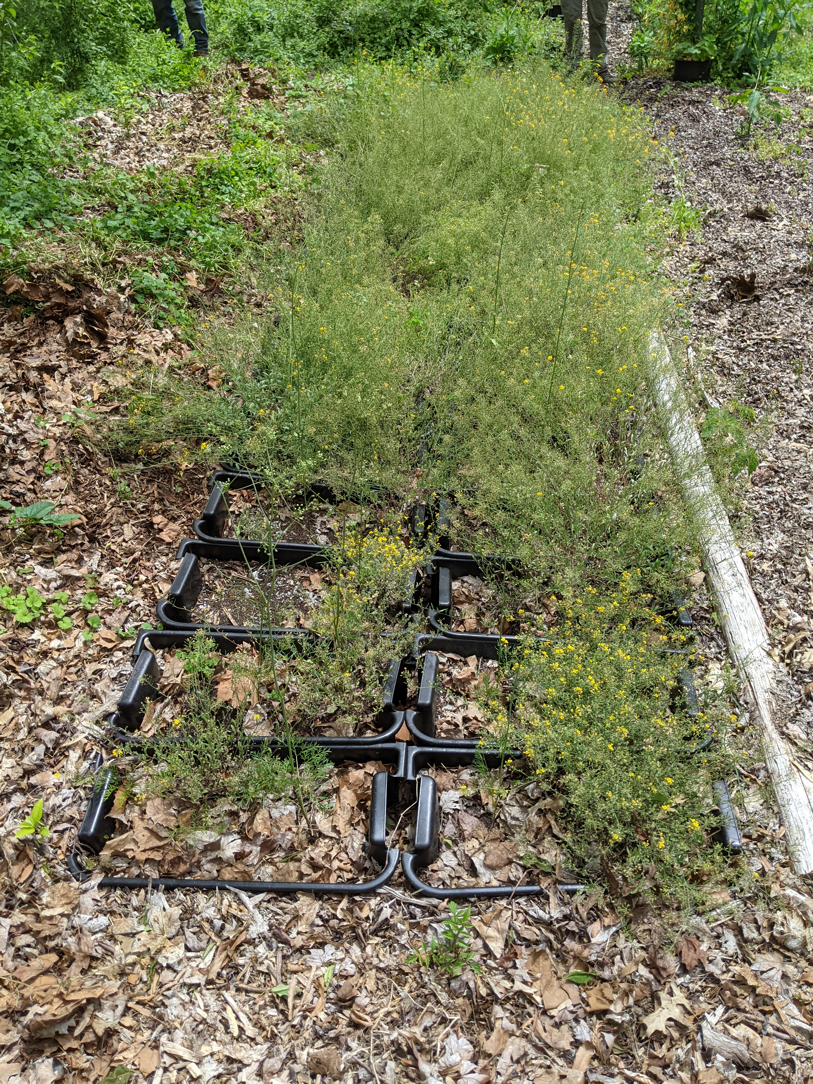 | C  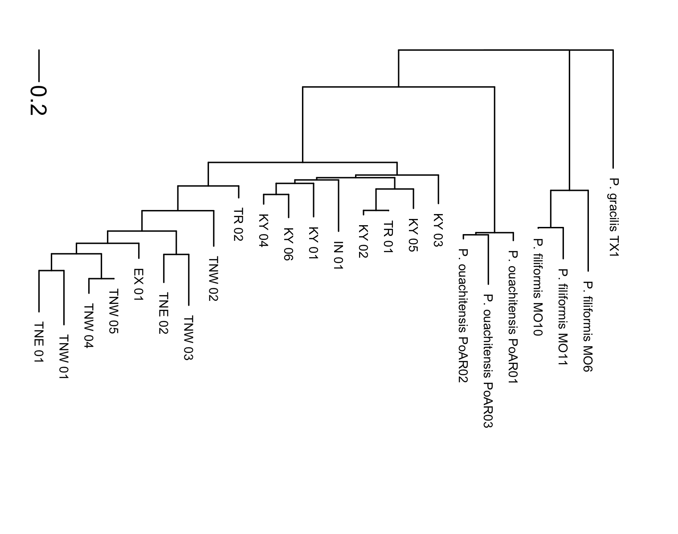

Figure 1. Photos of Physaria globosa and genetic distance tree.
(A), Native habitat. (B), Ex situ site (EX_01). (C), Neighbor-Joining tree based on Nei’s genetic distances. The tree was rooted at P. gracilis.

Figure 2. Map of P. globosa collection localities, with population structure K = 3 shown in pie charts.
The size of the pie chart reflects the sampling size per population. See Table 1 for detailed information.

A
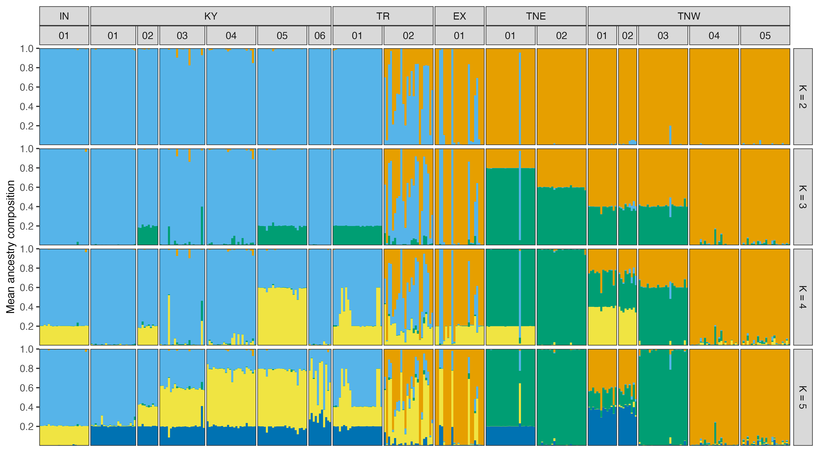
B  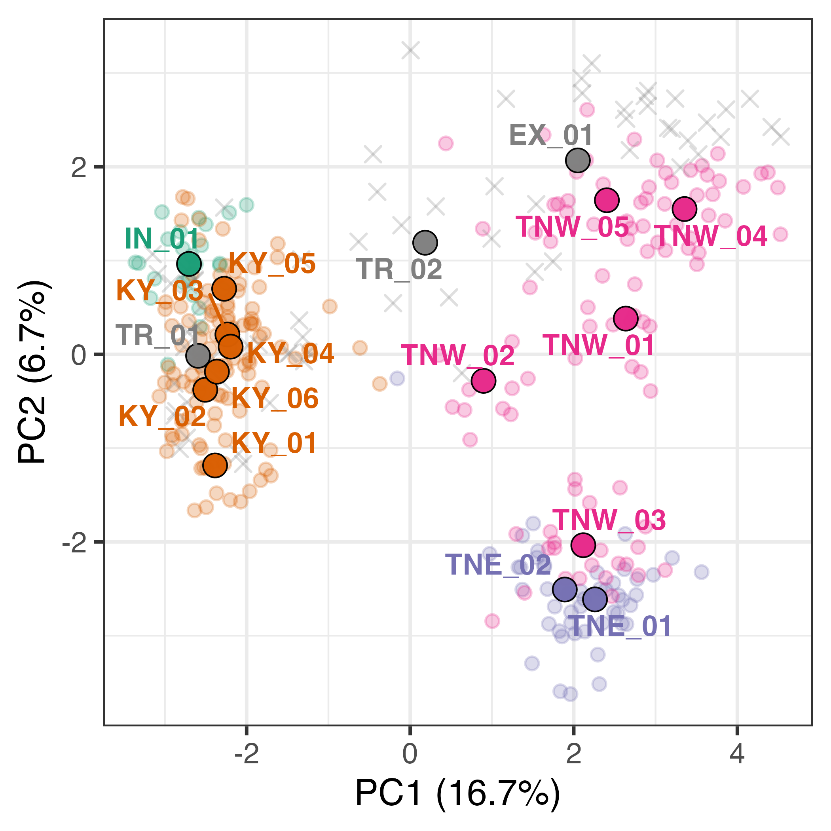 | C  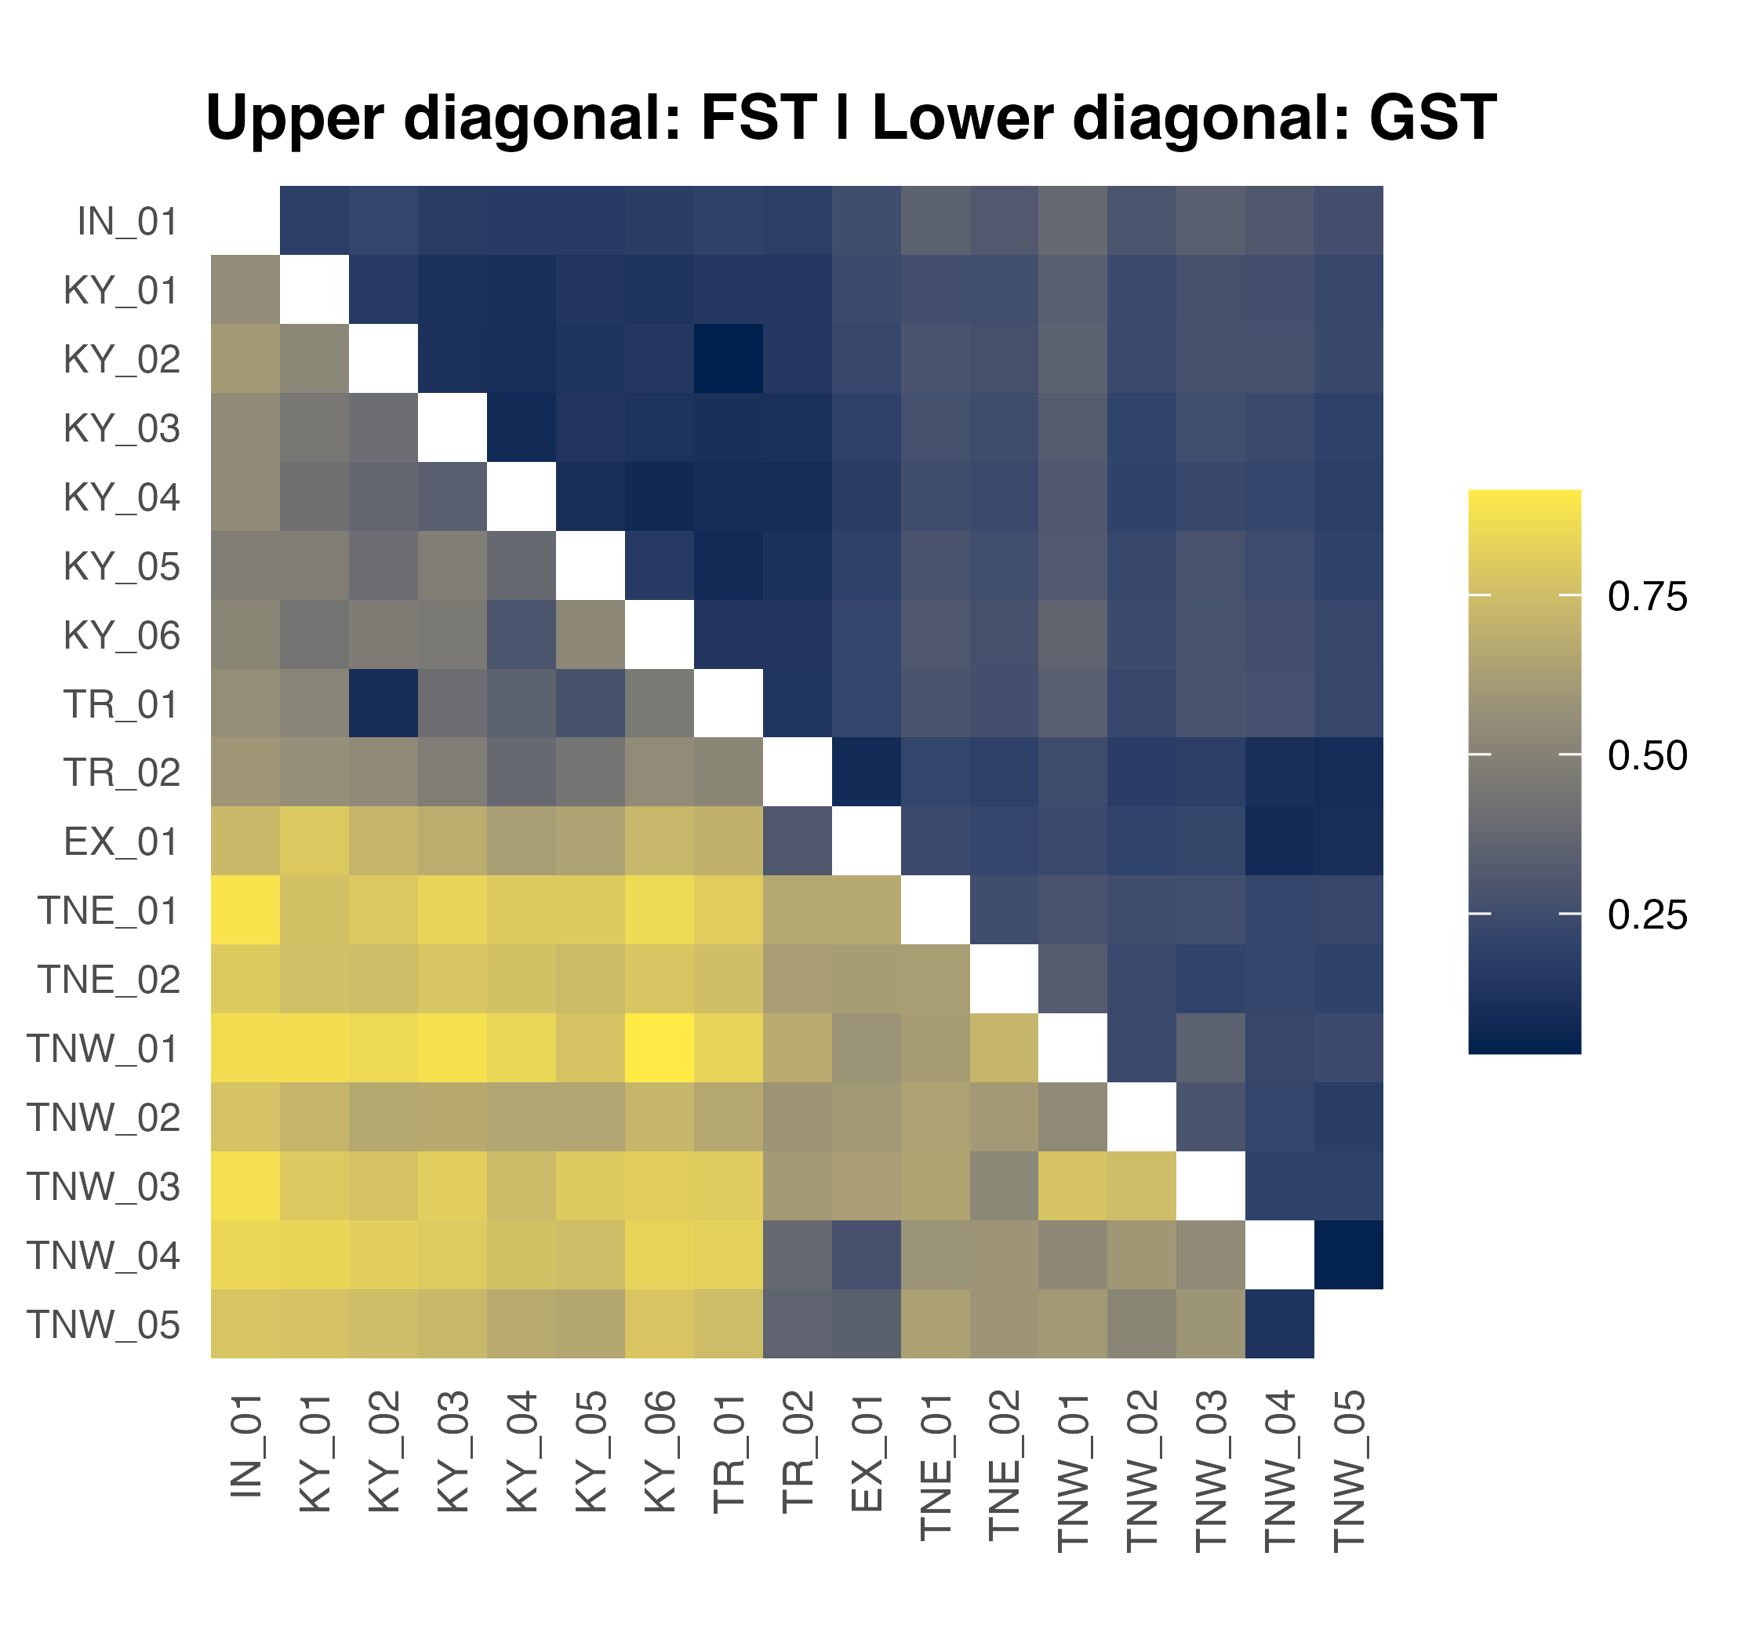

Figure 3. PCA of all wild P. globosa populations, with location and species indicated.
(A) STURCTURE analysis result (K = 2-5). (B) PCA plot. The big points with black stroke outline are population means. The small points without black stroke outline are individuals from natural populations. The crosses are individuals from ex situ populations. Points are colored by regions and population codes are labeled. (C), heatmap of F_{ST} and G_{ST}. See Table 1 for the population codes.
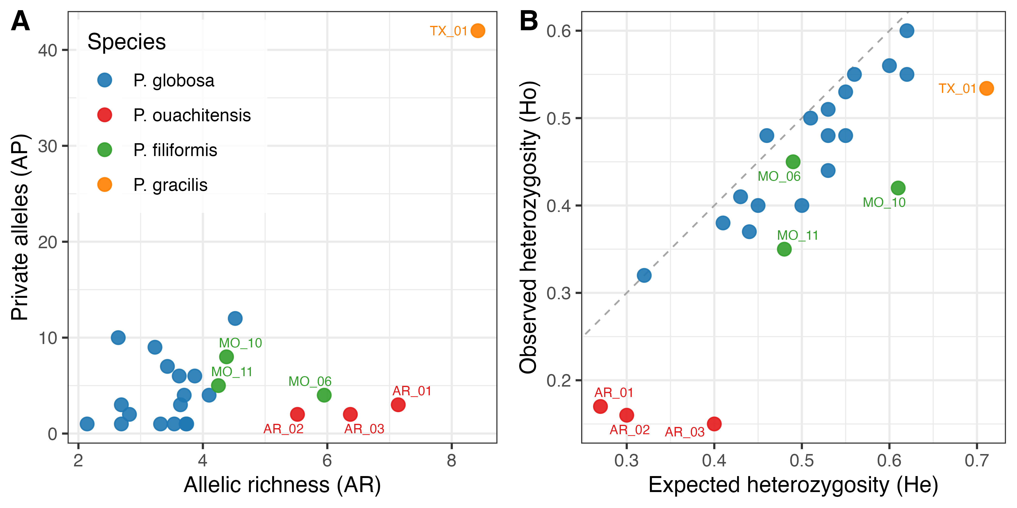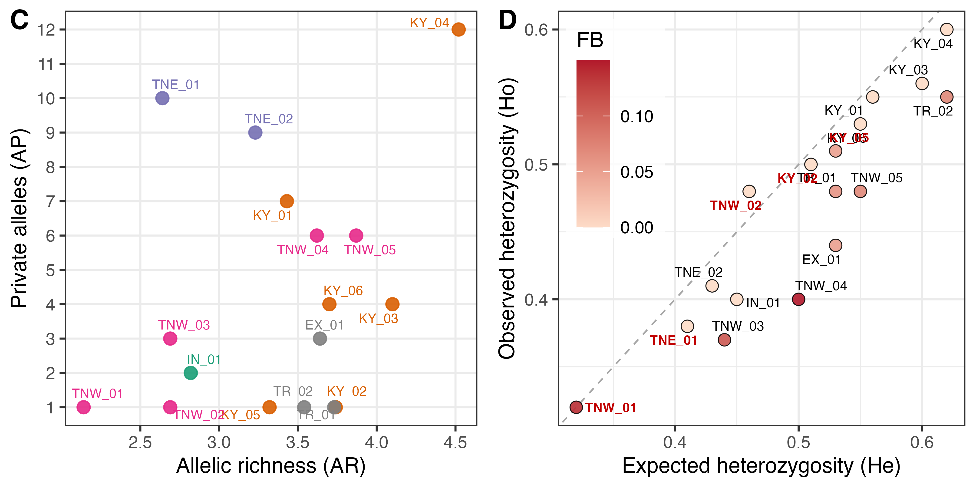

Figure 4. Genetic diversity analyses plots.
(A-B), Physaria globosa and outgroup species. (C-D), Physaria globosa with population labels. F_{B}., inbreeding coefficient after correction for null alleles. The six populations with excessive heterozygosity are labeled in red in (D). See Table 1 for the population codes.

